# 基础

搜索流或者包中的关键字

[协议名称] contains "你要搜索的内容"

过滤包的长度

frame.len==[长度]

过滤HTTP请求方法

http.request.method==POST

# 蚁剑流量

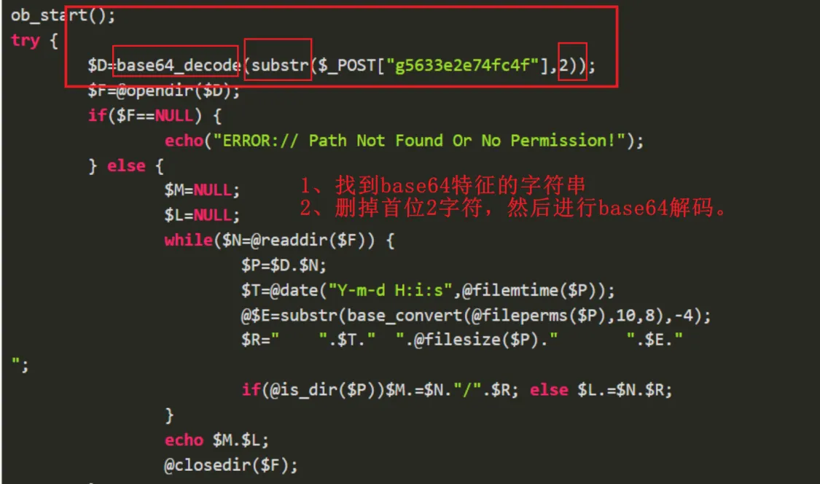

修改随机前缀长度：

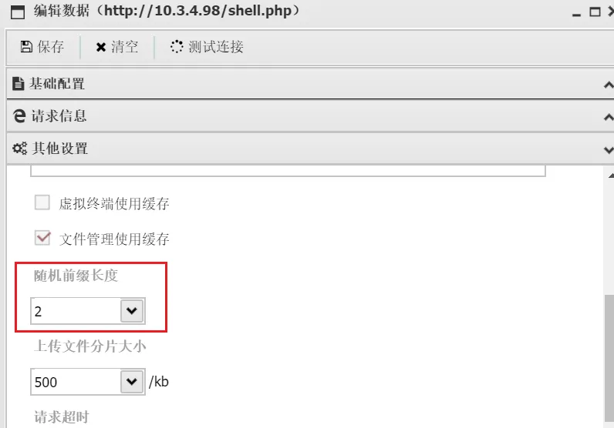

蚁剑流量特征：  
1、请求数据包加密，响应数据包明文显示。  
2、攻击者每执行一条命令，都会发送一次POST请求。

追踪流的：

* TCP：可以一个一个包看下去，针对像gzip，显示原始字节流
* HTTP：一个请求一个响应的包，一个请求包一个请求包的看

Gzip的文件头：1f 8b 08 00 ...  
蚁剑base64的webshell执行命令

substr($_POST["h37e8ca57159a8"],2))

文件->导出对象-HTTP

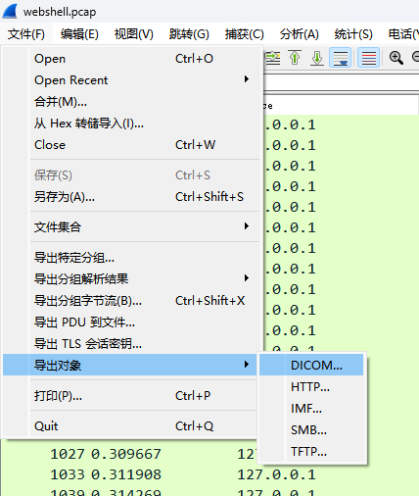

查看响应的包的内容：

* 1. 追踪TCP流，然后提取十六进制的字节流恢复
  2. 直接导出HTTP，然后查看每个包的请求和响应
  3. 直接追踪单个HTTP包，可直接查看当前响应内容

当流量很多的时候，一般前面放一些扫描流量用来干扰，直接从最后的流量包往前看，节省很多时间

# 冰蝎流量

默认密钥开头是 3Mn1yNMtoZViV5wotQHPJ

离线解密AES加密的冰蝎流量，模式：AES-128-CBC

PS C:\Users\Administrator> php -r "var_dump(openssl_decrypt('mAUYLzmqn5QPDkyI5lvSp0fjiBu1e7047YjfczwY6j707eSlJOR++rc2CLjN5Ka6PQEdaL2069K+yLT9EX0fYg==', 'AES-128-CBC', 'e45e329feb5d925b'));"  
Command line code:1:  
string(50) "{"status":"c3VjY2Vzcw==","msg":"MTcyLjE3LjAuMgo="}"  
PS C:\Users\Administrator> php -r "var_dump(base64_decode('MTcyLjE3LjAuMgo='));"  
Command line code:1:  
string(11) "172.17.0.2"

Cyberchef解密：  
偏移量为：0000000000000000000000000000000

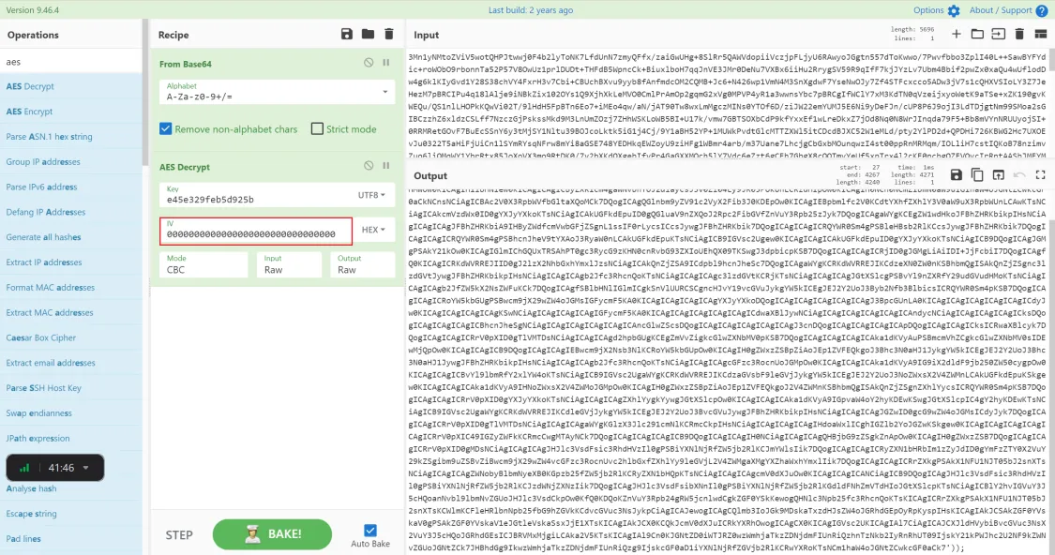

冰蝎4

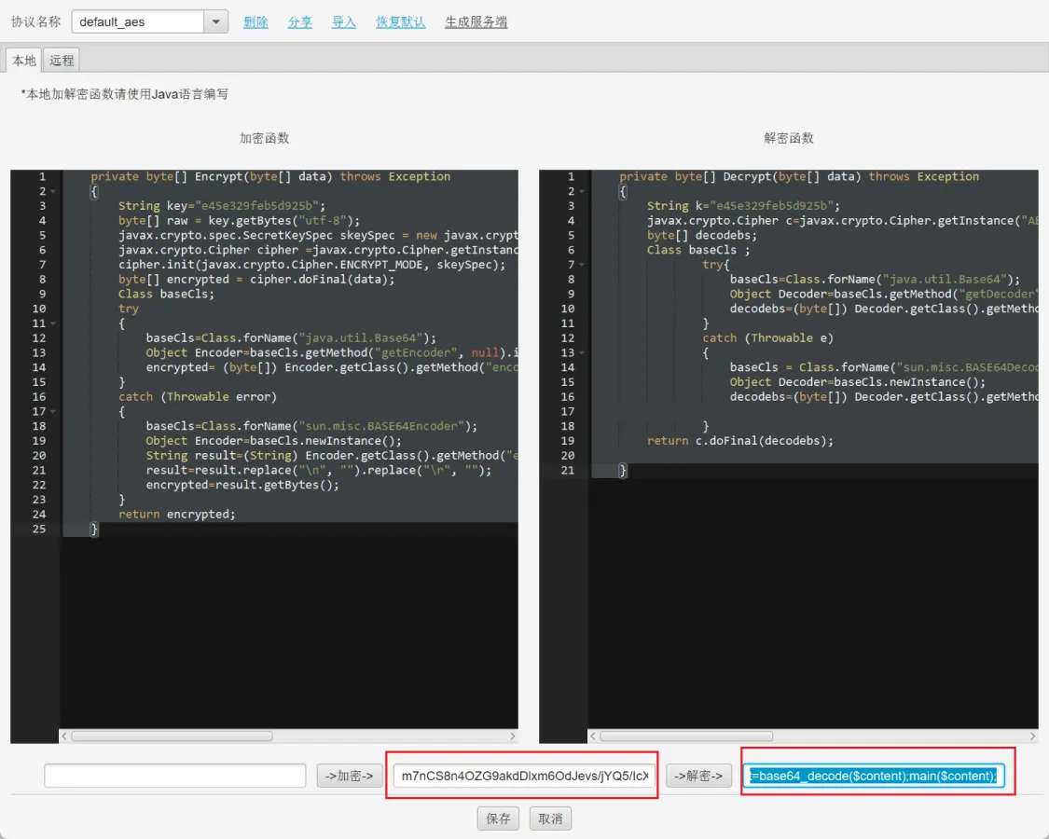

# 键盘流量

工具：<https://github.com/seadog007/UsbKeyboardDataHacker>  
USB的 usb.capdata 字段就是存储键盘输入的键位，长度默认是16位，八个字节

data = '0000020000000000'  
  
第一个字节: 02是否按下了Shift data[:2]  
第三字节：键位

# -*- coding: utf-8 -*-  
import re  
  
normalKeys = {"04": "a", "05": "b", "06": "c", "07": "d", "08": "e", "09": "f", "0a": "g", "0b": "h", "0c": "i",  
 "0d": "j", "0e": "k", "0f": "l", "10": "m", "11": "n", "12": "o", "13": "p", "14": "q", "15": "r",  
 "16": "s", "17": "t", "18": "u", "19": "v", "1a": "w", "1b": "x", "1c": "y", "1d": "z", "1e": "1",  
 "1f": "2", "20": "3", "21": "4", "22": "5", "23": "6", "24": "7", "25": "8", "26": "9", "27": "0",  
 "28": "<RET>", "29": "<ESC>", "2a": "<DEL>", "2b": "\t", "2c": "<SPACE>", "2d": "-", "2e": "=", "2f": "[",  
 "30": "]", "31": "\\", "32": "<NON>", "33": ";", "34": "'", "35": "<GA>", "36": ",", "37": ".", "38": "/",  
 "39": "<CAP>", "3a": "<F1>", "3b": "<F2>", "3c": "<F3>", "3d": "<F4>", "3e": "<F5>", "3f": "<F6>",  
 "40": "<F7>", "41": "<F8>", "42": "<F9>", "43": "<F10>", "44": "<F11>", "45": "<F12>"}  
  
shiftKeys = {"04": "A", "05": "B", "06": "C", "07": "D", "08": "E", "09": "F", "0a": "G", "0b": "H", "0c": "I",  
 "0d": "J", "0e": "K", "0f": "L", "10": "M", "11": "N", "12": "O", "13": "P", "14": "Q", "15": "R",  
 "16": "S", "17": "T", "18": "U", "19": "V", "1a": "W", "1b": "X", "1c": "Y", "1d": "Z", "1e": "!",  
 "1f": "@", "20": "#", "21": "$", "22": "%", "23": "^", "24": "&", "25": "*", "26": "(", "27": ")",  
 "28": "<RET>", "29": "<ESC>", "2a": "<DEL>", "2b": "\t", "2c": "<SPACE>", "2d": "_", "2e": "+", "2f": "{",  
 "30": "}", "31": "|", "32": "<NON>", "33": "\"", "34": ":", "35": "<GA>", "36": "<", "37": ">", "38": "?",  
 "39": "<CAP>", "3a": "<F1>", "3b": "<F2>", "3c": "<F3>", "3d": "<F4>", "3e": "<F5>", "3f": "<F6>",  
 "40": "<F7>", "41": "<F8>", "42": "<F9>", "43": "<F10>", "44": "<F11>", "45": "<F12>"}  
  
def filterProcess(output):  
 content = output.replace('<SPACE>', ' ')  
 while True:  
 if '<DEL>' in content:  
 content = re.sub(r'[^>]<DEL>', '', content)  
 else:  
 break  
 return content  
  
with open('usbData.txt', 'r') as f:  
 output = ""  
 lines = f.readlines()  
 for line in lines:  
 ifShiftKeys, usbData = line[0:2], line[4:6]  
 if usbData != "00":  
 if ifShiftKeys == "00":  
 if usbData in normalKeys:  
 output += normalKeys[usbData]  
 elif ifShiftKeys == "02": # 按下了Shift键  
 if usbData in shiftKeys:  
 output += shiftKeys[usbData]  
print("[+]Output: {}\n".format(output))  
print("[+]Filter Processed: {}".format(filterProcess(output)))

USB流量存储的字段名称：usb.capdata 或者 usbhid.data

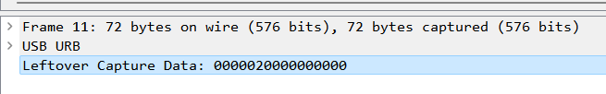

# 鼠标流量

工具：<https://github.com/WangYihang/USB-Mouse-Pcap-Visualizer>

00020400  
  
长度默认为8  
第一个字节：01表示左键，02表示按下右键，00没有按键  
第二个字节：表示的横坐标x  
第三个字节：表示的纵坐标y

import matplotlib.pyplot as plt  
from PIL import Image  
  
def drawMiceData():  
 with open('MiceData.txt', 'r') as f:  
 lines = f.readlines()  
 currentPosX, currentPosY = 0, 0  
 with Image.new('1', (2000, 1000), 1) as img:  
 for line in lines:  
 line = line.strip()  
 if len(line) == 8:# 鼠标流量的长度为8，键盘流量的长度为16  
 pos_x, pos_y = int(line[2:4], 16), int(line[4:6], 16)  
 if pos_x > 127:  
 pos_x -= 256  
 if pos_y > 127:  
 pos_y -= 256  
 currentPosX += pos_x  
 currentPosY += pos_y  
 buttonFlag = int(line[:2]) # 0表示没有按下，1表示鼠标按下左键，2表示鼠标按下右键  
 if buttonFlag == 2:  
 img.putpixel((currentPosX, currentPosY), 0)  
 img.show()  
 # plt.scatter(currentPosX, currentPosY, color='r', s=1)  
 # plt.show()  
  
  
if __name__ == '__main__':  
 drawMiceData()

# 工控流量

<https://xz.aliyun.com/t/6603>